 | Private Bag X69, Braamfontein, 2017  29 de Korte Street, Braamfontein,  2001,  Tel: (011) 403-9990, Fax: (011) 403-7891 / 403-4379
   | Private Bag X69, Braamfontein, 2017  29 de Korte Street, Braamfontein,  2001,  Tel: (011) 403-9990, Fax: (011) 403-7891 / 403-4379
In the matter between:

WILSON SHINGANGE Union /Employee party

And

PALM TREE DISTRIBUTORS Employer Party

AWARD

Case number: RFBC25053

Union/Employee’s Representative: SELF

Union/Employee’s Address: 11 DRIFT STREET
UNIGREY STEELDALE
2001
Telephone: 076 922 1483 Fax:

Employer’s Representative: BEN MATLALA

Employer’s Address: 19 ELIS ROAD
ALRODE SOUTH
1451

Telephone: (011) 900-3862 Fax: (011) 868-1565
(031) 469-2202
DETAILS OF HEARING AND REPRESENTATION

Commissioner Johnston issued a certificate of outcome in this matter on the 12th April 2013 certifying that the dispute between Wilson Shingange (“The Employee”) and Palmtree Distributors (“the Employer”) remains unresolved. The Employee served and filed his Request for Arbitration on the 12th April 2013. The matter was scheduled for arbitration on the 19th June 2013. Both parties were present at this hearing. The Applicant was present and unrepresented and the Respondent was represented by Mr Ben Matlala, human resources manager.

POINT-IN-LIMINE
The Employer raised a point-in-limine that the Council did not have jurisdiction to proceed with this matter as the matter was resolved on the 25th February 2013 under case number RFBC24229. The terms of the settlement included holding a disciplinary hearing on the 28th February 2013 for the Employee. The Employee was served with the charge sheet and bundle of documents at the conciliation hearing. It was further agreed that the Employee would refer his dispute relating to his commission and pay during his suspension period to the Council’s compliance department. The Employee’s dispute in this matter relates to his commission and pay during his suspension period and should therefore be referred as a compliance issue.
The Employer held the disciplinary hearing on the 28th February 2013 in accordance with the terms of the settlement. However, the Employee walked out of the hearing . The chairperson decided to postpone the hearing and new charges were added to the existing charges. The Employee was served with the new charge sheet and the hearing was held on the 8th March 2013. The Employee did not attend the hearing and the hearing proceeded in his absence. The outcome of the hearing was handed down on the 11th March 2013. The Employee was not suspended on the 28th February 2013. The Employee was paid his salary until the 11th March 2013.

The Employee submitted that he was not paid his monies during the period of his suspension. He did not receive the notice of his dismissal although he was informed he was dismissed. He did not receive the notice of the disciplinary hearing of the 8th March 2013. He walked out of the hearing on the 28th February 2013 because the Employer was forcing him to sign blank documents and his witness was not present. His dispute relates to the non-payment of his salary during the period of his suspension.

ANALYSIS OF SUBMISSIONS
The Employee referred his dispute to the Council on the 20th March 2013 as a section 186(2)(b) dispute. The Employee acknowledged that he was informed by the Employer that he was dismissed while the Employer submitted that he was dismissed on the 11th March 2013. It is clear that the Employee was not suspended at the time of this referral. The Employee was unequivocal that his dispute related to the non-payment of his salary during the period of his suspension. The settlement agreement concluded between the parties on the 25th February 2013 states as follows:
“1. The Applicant as has been informed that his disciplinary hearing will take place on Thursday, 28/02/2013 at 11h00 at the company premises.
- The Applicant has received the charge sheet and bundle of documents .
- The Applicant will refer the dispute regarding the commission and pay during period of suspension to the Council’s compliance department.”
It is clear that the Employee agreed at the conciliation hearing of the 25th February 2013 that he would refer his dispute about the non-payment of his salary during the period of his suspension to the Council’s compliance department. He has now, in essence, referred a new dispute to the Council about an issue that was already resolved at the conciliation hearing.

RULING
It is clear that the Employee must refer the dispute about the non-payment of his salary during the period of his suspension to the Council’s compliance department in accordance with the settlement agreement of the 25th February 2013.

SIGNED AND DATED AT BRAAMFONTEIN ON THIS THE 29th DAY OF JUNE 2013.
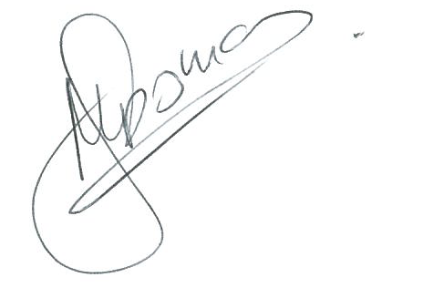
__________________________

MOHINI SOMAN
NBCRFI PANELLIST

