 | Private Bag X69, Braamfontein, 2017  29 de Korte Street, Braamfontein,  2001,  Tel: (011) 403-9990, Fax: (011) 403-7891 / 403-4379
IN LIMINE RULING

Arbitrator: B.S Mthethwa
Case Reference No.: GPRFBC25744
Date of Ruling: 10 July 2013

In the matter between:

Nhlanhla Yende

Union/Applicant

And

Supergroup Trading (Pty) Ltd

Respondent

Details of hearing and representation

1. This is an opposed application and shall be determined in terms of Rule 37 of the Council Rules (“the Rules”) on papers.

Issues to be decided

2. I must decide whether or not the late filing of the dispute by the applicant should be condoned.

Background to the issue

3. The applicant was allegedly dismissed on 5 April 2013.

4. The applicant has now applied for the late referral of the application to be condoned in terms of section 191 (2) of the LRA.

5. Section 191 (2) gives the Council authority to condone any failure to comply with the time frames, on good cause shown. In considering whether to condone lateness of filing I am required to consider the following:

(i) Degree of lateness:

6. This is a matter that involves an alleged unfair dismissal. The applicant was dismissed on 5 April 2013, and the dispute was referred to the Council on 15 May 2013 according to the record on file. Thus the matter was referred 9 days late.

(ii) Reason(s) for the lateness:

7. The applicant submitted that he had referred the dispute outside the prescribed period because he was still waiting for the appeal hearing.

8. The respondent disputed that the applicant filed for an appeal hearing.

(iii) Prospects of success on the merits of the case:

9. The applicant submitted that he was not responsible to load a truck yet he was dismissed for the missing consignment.

10. The respondent noted that both the applicant and the driver were responsible for the consignment. The consignment went missing and was not accounted for.

(iv) Prejudice to the parties:

11. The respondent noted that the delay in referring this matter would negatively impacted on evidentiary evidence.

Analysis of the submissions

12. In my view the applicant’s failure to comply with the statutory time frame should be viewed against the background that he was waiting for the appeal hearing. I have also noted that the respondent disputed that the applicant had filed for an appeal hearing. However, the lateness of this application was very minimal.

13. Furthermore the applicant had brought this application unassisted. Thus I am of the opinion that the applicant has advanced acceptable explanation for the delay in the instance.

14. With regards to the merits of the case the applicant submitted that he did not load the consignment in question. On the other hand the respondent contended that the applicant and the driver were responsible for the missing consignment. In light of the contentions before me I am of the opinion that the applicant appears to have good prospects of success in the main application.

15. Accordingly, in my view this dispute requires a factual inquiry and thus a proper ventilation of the matter at arbitration should be allowed. As to prejudice, I am of the view that given the applicant’s explanation for the delay (which I accept) together my with findings on his prospects of success, any potential prejudice to the respondent in granting this application is outweighed by the prejudice that would be suffered by the applicant in case this application fails.

16. In the circumstances I make the following ruling:

Ruling:

17. Condonation is granted.
18. Certificate of non-resolution is issued.

19. The applicant may apply for arbitration, if he elects to pursue this matter.

20. I make no order as to costs.

THUS DONE AND SIGNED AT JOHANNESBURG ON THIS 10TH DAY OF JULY 2013

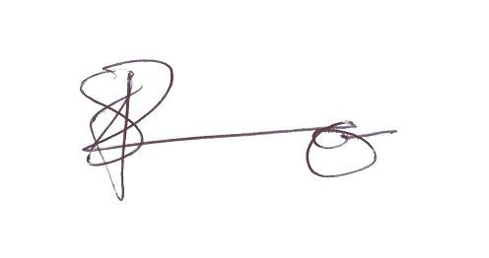

____________________________________________
NBCRFI Panelist: Bhekinhlanhla Stanley Mthethwa

