 | Private Bag X69, Braamfontein, 2017  29 de Korte Street, Braamfontein,  2001,  Tel: (011) 403-9990, Fax: (011) 403-7891 / 403-4379  IN LIMINE RULING  Arbitrator: B.S Mthethwa  Case Reference No.: GPRFBC22977  Date of Ruling: 3 December 2012
   | Private Bag X69, Braamfontein, 2017  29 de Korte Street, Braamfontein,  2001,  Tel: (011) 403-9990, Fax: (011) 403-7891 / 403-4379
  Private Bag X69, Braamfontein, 2017
  29 de Korte Street, Braamfontein,
  2001,
  Tel: (011) 403-9990, Fax: (011) 403-7891 / 403-4379

In the matter between:

Maehleni Simon Nkosi

Union/Applicant

And

Barlowworld Logistics

Respondent

Details of hearing and representation

1. This is an unopposed application and shall be determined in terms of Rule 33 of the Council Rules (“the Rules”) on papers.

Issues to be decided

2. I must decide whether or not the late filing of the dispute by the applicant should be condoned.

Background to the issue

3. The applicant was allegedly dismissed on 12 July 2012.

4. The applicant has now applied for the late referral of the application to be condoned in terms of section 191 (2) of the LRA.

5. Section 191 (2) gives the Council authority to condone any failure to comply with the time frames, on good cause shown. In considering whether to condone lateness of filing I am required to consider the following:

(i) Degree of lateness:

6. This is a matter that involves an alleged unfair dismissal. The applicant was dismissed on 12 July 2012, and the dispute was referred to the Council on 8 October 2012 according to the record on file. Thus the matter was referred 85 days late.

(ii) Reason(s) for the lateness:

7. The applicant submitted that he was not aware of the prescribed period in referring a matter. He only realized when he approached a legal practitioner of the timeframes involved.

(iii) Prospects of success on the merits of the case:

8. The applicant also submitted that there was no evidence to convict him. His services were terminated for being involved in an accident.

(iv) Prejudice to the parties:

9. Prejudice was not argued.

Analysis of the submissions

10. The condonation application is uncontested. In analyzing whether the applicant has shown good cause I conclude in the following:

- The degree of lateness is substantial.
- The applicant has provided a reasonable explanation for the delay in referring the matter.
- It is highly probable that the applicant was dismissed without a fair and valid reason.
- There appear to be good prospects of success.
- The applicant has shown every intention to pursue his rights.
- The applicant will suffer prejudice if the case is not heard.

11. For all the above reasons; I am of the view that the applicant has shown good cause for granting condonation.

Ruling

12. Condonation is granted.
13. Certificate of non-resolution is issued.

14. The applicant is free to apply for arbitration, if he elects to pursue this matter.

15. I make no order as to costs.

THUS DONE AND SIGNED AT JOHANNESBURG ON THIS 3RD DAY OF DECEMBER 2012

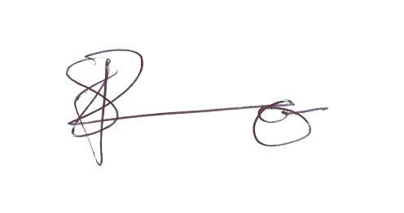

RFBC Arbitrator: Bhekinhlanhla Stanley Mthethwa

